ChronoZoom

The Mood/Contentment Chart

**Greetings Chronozoomers!**

In order to understand how different individual countries reacted to key events in the lead up to World War I you must gauge the anger/happiness level of the leaders of each country over time. This initial step is vital to our process of determining how specific events impacted different countries in different ways.

* Did a set impact the leaders of a country in a different way?
* Did an event leave one country more angry/threatened than the leaders in another country?
* Did one event have no impact on one country while having a significant impact on another country?

If we are to understand the correlation between discontentment and war, and identify which events held the greatest significance in leading specific nations to go to war, it is vital to understand the viewpoints of individual nations.

This is a challenging task, but with ChronoZoom we can do this.

Your mission commander will provide you with a profile of a specific country as well as a mood chart.

On the vertical axis you will be able to plot anger and discontent ☹ as well as happiness and contentment ☺. The line is the middle indicates that the event had a minimal impact on your assigned nation.

Place key dates along the horizontal axis. Your mission commander will detail the scale you should use to log dates. Depending on your focus your time scale could be in years, months or weeks or days. You might end up using one chart to look at events over a long period (e.g. 1871- 1910) and another chart to look at events that occurred over a few weeks or days (e.g. the July Crisis of 1914).

Then use ChronoZoom to label and plot the dates of key events onto your chart. Pay close attention to where you place the event on the “anger/happy” line.

For each date, indicate whether the event created anger and frustration, and why.

Go to it, Chronozoomers.

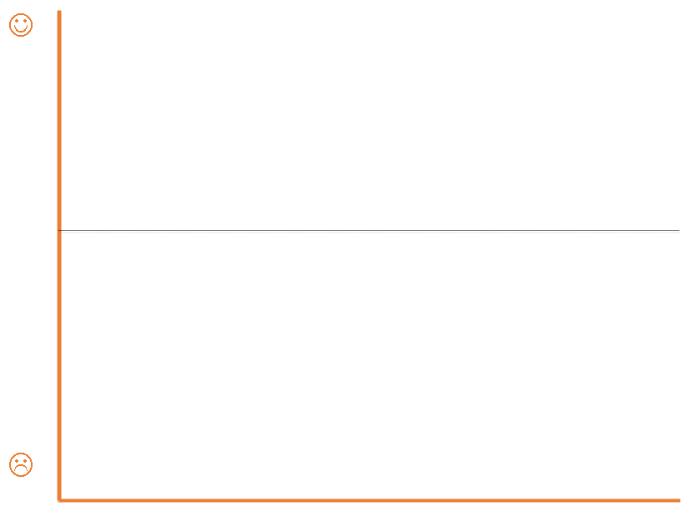

Dates (5 year increments)

Nation's (dis)content/(un)happiness with specific events